**Argrett Lab 4**

Still working with only the shrubland site data for now (site = C), let’s consider the same effects of treatment and substrate type on a different measure of biocrust activity, scytonemin concentration. Remember to include the code chunk that led to your answer to each question. 24 points.

1. Try to run the same lm() model we tried with chlorophyll, but with scytonemin (raw values) as the response instead. Paste a qqplot of the residuals of the model below. Are the residuals normally distributed? (2 points for figure, 2 points for answer)

The residuals do not fall within the line or the confidence interval thus the data is not normal.

2. Try the model again, this time log-transforming scytonemin values to fit normality assumptions. Make sure to check if there are any zeros before you log-transform! Paste a qqplot of the model residuals below, as well as a plot of residuals vs. fitted values to check for heteroscedasticity. (2 points each plot)

3. It’s not perfect, but it will do. Let’s proceed with analysis. Using Anova(), on the model, test the null hypotheses that scytonemin concentrations are the same across substrates, treatments, and their interaction. Paste your ANOVA table below. What is your conclusion? (2 points for table, 2 points for answer)

Location seems to be the only response variable with a significant interaction with scytonemin concentration.

4. Using emmeans(), let’s investigate the pairwise differences among the levels in the significant effect(s). Provide your emmeans() code. What is your conclusion? (2 points for code, 2 points for answer)

em<-emmeans(cm2, specs=pairwise~Treatment|Location)

em2<-emmeans(cm2, specs=pairwise~Location)

em2$contrasts %>%

rbind(adjust="tukey")

There is no significant difference within treatments but there is a significant difference between interspace Scytonemin concentrations between the two substrate types and the interspace.

5. To visualize the results of these analyses, make a plot that has all the components of the plot below (error bars are SE). Provide your code, your figure, and a figure caption. Feel free to do different colors/labels, but make sure that your plot includes the significant labels for pairwise comparisons. Hint, try annotate(). (4 points for figure and code)

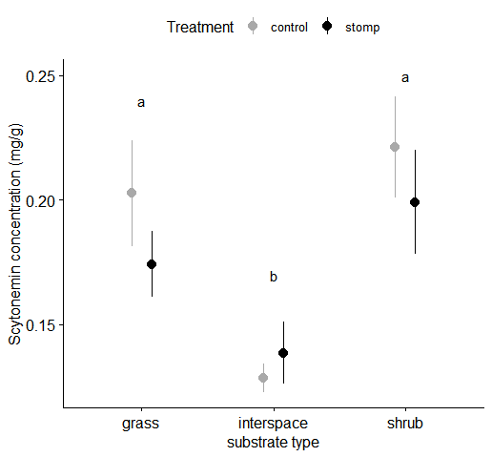

Figure 1. Comparison of Substrate type and Scytonemin concentrations by treatment. There is no significant difference between treatments. However, Scytonemin concentrations differed significantly between the interspace vs. grass (p < .0001) and interspace vs. shrubland (p < .0001).

p <- ggerrorplot(data=data.C, x="Location", y="Scytonemin_mgperg",

color="Treatment",palette=c("blue","orange"),

desc_stat = "mean_se",

width=1,

position = position_dodge(0.3),

xlab="Substrate Type", ylab="Scytonemin Concentration (mg/g)",

size=1) +

font("xlab", size = 14, color = "black") +

font("ylab", size = 14, color = "black")

p

p2 <- p+scale_x_discrete(labels=c("Grass", "Interspace", "Shrub")) +

coord_cartesian(ylim=c(NA, 0.25)) +

annotate("text", x=1, y=0.24, label=c("a")) +

annotate("text", x=2, y=0.17, label=c("b")) +

annotate("text", x=3, y=0.25, label=c("a"))

p2

6. Write a discussion fragment (few sentences) that compare the effects of stomping disturbance and substrate type in shrublands on chlorophyll vs. scytonemin using the results in class and your results here. (4 points)

Disturbance had a negative impact on both chlorophyll and scytonemin concentrations in the shrubland. Scytonemin concentrations were only affected by substrate type while chorolophyll was impacted by both substrate type and the stomping treatment. Grassland plots that were stomped had significantly less chlorophyll than the control plots. Pulling meaning from our findings, grassland cholorophyll concentrations in the biocrust are significantly impacted by disturbance in comparison with scytonemin, which protects cyanobacteria from UV radiation. It can be gleamed then that the negative impact of disturbance on the interspace, where no protection from UV radiation is present is strongest for scytonemin concentrations. While this effect is not significant near grasses and shrubs, biocrust that is associated with grasses seems to have a stronger negative response to disturbance only on clorophyll concentration which is probably due to the lack of need for as high scytonemin concentrations in the biocrust due to partial protection from the plants.